Iowa State University

4G LTE Network Emulation and Throughput Testing Utilizing ARA

Senior Design sdmay24-20 Experimental Lab



Before starting this lab, familiarize yourself with the basics of 4G network infrastructure by visiting [A Beginners Guide to Mobil Communication Infrastructure](https://www.packetcoders.io/a-beginners-guide-to-mobile-wireless-communication-infrastructure/) and reading the section regarding 4G networks. To understand the platform that you will be using read about the ARA sandbox [ARA Sandbox Service](https://arawireless.readthedocs.io/en/latest/ara_technical_manual/sandbox_service.html).

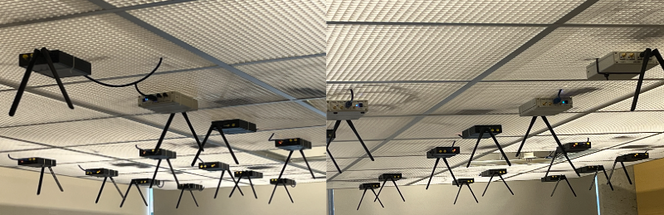

Objectives:

1. Successfully set up an emulated 4G network and simulate data traffic between the UE and EPC.
2. Conduct a throughput test on the emulated network and analyze performance.

Learning objectives:

1. Gain an understanding of the key components of a 4G network and their responsibilities.
2. Define metrics that can affect the throughput of a network.
3. Get experience utilizing SDRs in a lab environment.

Time to complete this lab: 1-1.5 hrs

This lab must be completed in a single sitting because the containers don’t save data once deleted.

If you have signed up for ARA’s jumpbox make sure that you have the RSA private key you use in the .ssh file of the machine you plan to use to work on the lab.

**Table of Contents**

1) Log on to the ARA portal. 4

2) Reserve two sandbox hosts. 5

3) Create two containers. 12

4) Connect to containers using jumpbox. 18

5) Starting the EPC and eNB 22

6) Starting the UE 23

7) Running the throughput test 23

8) (Optional) create new UE 23

9) Deleting Leases 23

# Log on to the ARA portal.

* 1. Using your school credentials, log in at [ARA log-in portal](https://portal.arawireless.org/auth/login/?next=/project/leases/).

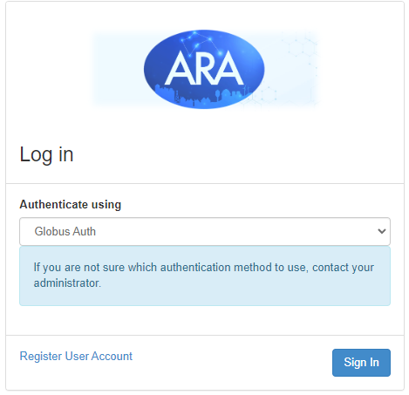

* 1. Search for “Iowa State University” in the search bar and press continue to be redirected to Okta.

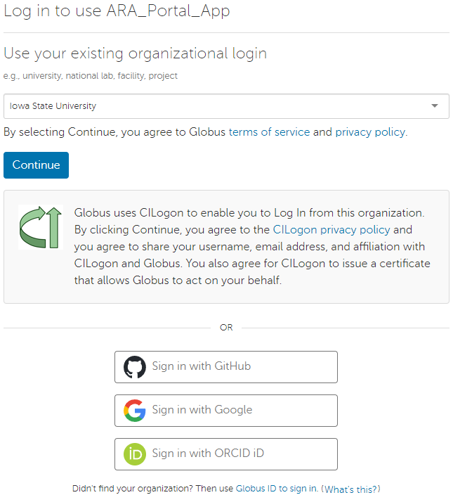

# Reserve two sandbox hosts.

* 1. Go to [ARA Sandbox Service](https://arawireless.readthedocs.io/en/latest/ara_technical_manual/sandbox_service.html) and pick two machines. Any two machines in a cluster like those in the image below are a good choice. For future examples, Sandbox-Host 006 and Sandbox-Host 009 will be used.

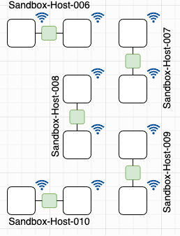

* 1. On the ARA portal, navigate to Reservations → Leases → Host Calendar

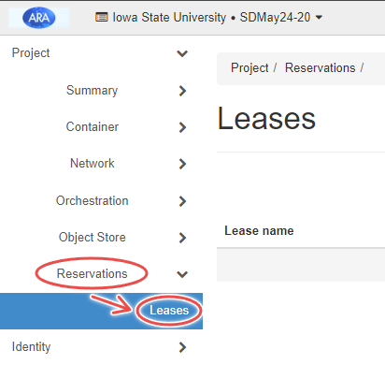 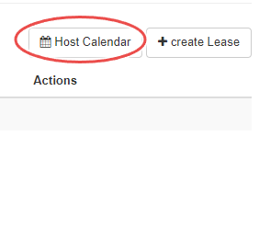

* 1. Ensure the hosts you chose are free to reserve. The image below shows Sandbox-Host-006 and 009 are available. Sandbox-Host 003 is currently reserved see reservation details by hovering your mouse over the colored block.

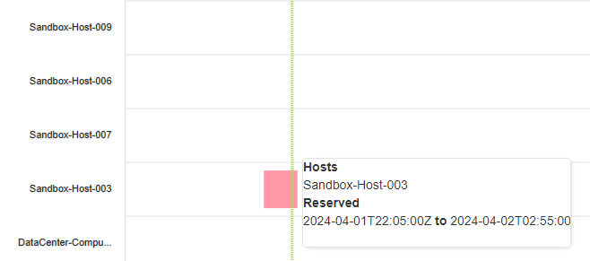

* 1. Create the first lease by clicking create lease next to host calendar.

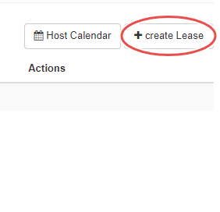

* 1. You can choose a lease name. However, using eNBLease as the lease name is recommended to make things less confusing moving forward. The start and end date can be left blank.

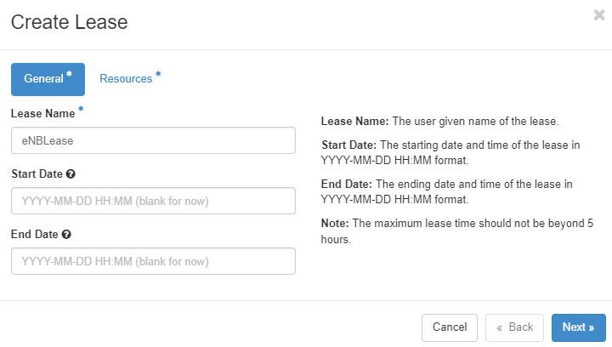

* 1. Use the Site dropdown menu and select Sandbox. Use the trailing numbers from Sandbox-Host-xxx for the device ID. For example, I will use Sandbox-Host-006.

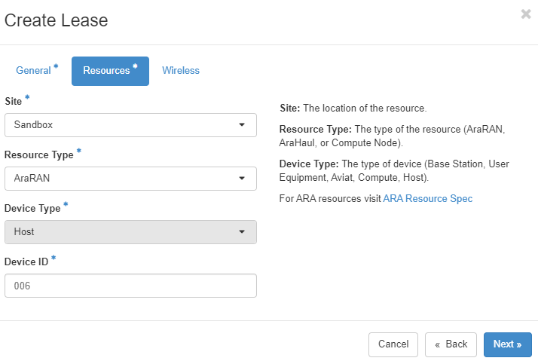

* 1. Leave the wireless section of the lease blank and click create lease.

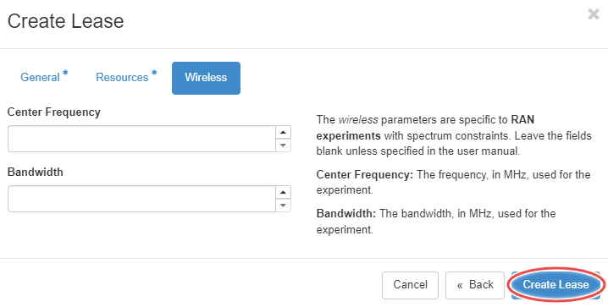

* 1. If done correctly with an available host the following messages will appear at the top right of the screen.

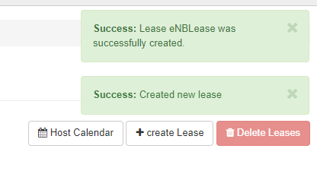

* 1. Do the same for the second lease using your other available host. Using the lease name UELease is recommended to avoid confusion later. For Example I use Sandbox-Host-009

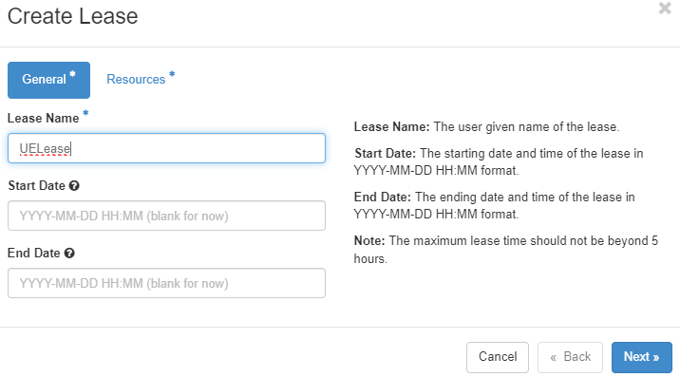

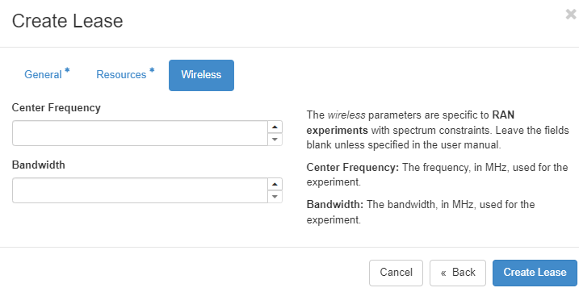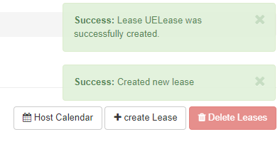

* 1. Provide a screenshot of both of the successfully created hosts’ lease details in your lab report. To see lease details click on the blue lease name.

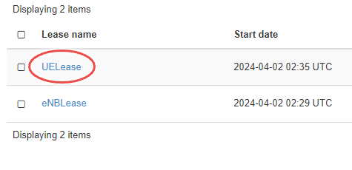

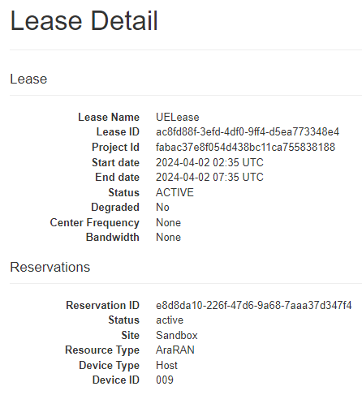

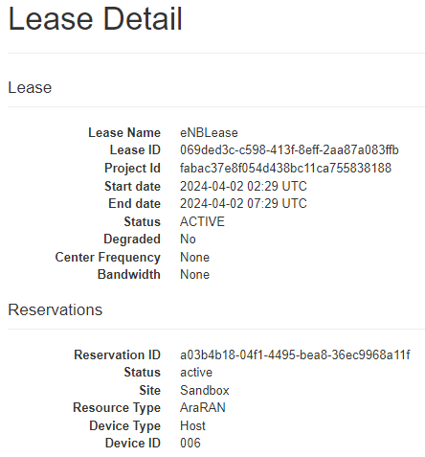

# Create two containers.

* 1. Navigate to Container → Containers → Create Container.

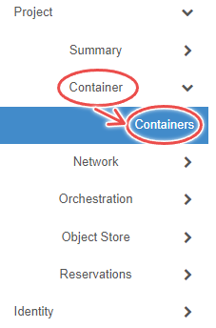 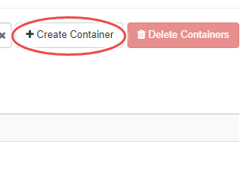

1. For the first container, choose a name. It is recommended to use “eNBContainer” for the name to avoid confusion. Use the docker image arawirelesshub/srsran:srsenb

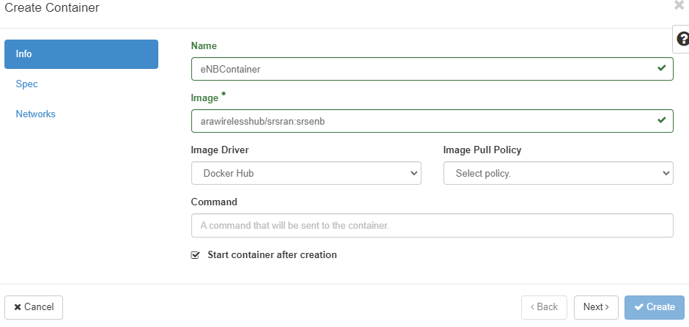

1. Fill in the Spec tab with the following specs.

* **Hostname:** eNB (recommended, but you can choose)
* **CPU:** 6
* **Memory:** 8192
* **Lease Name:** eNBLease (or the name you chose for the first lease).

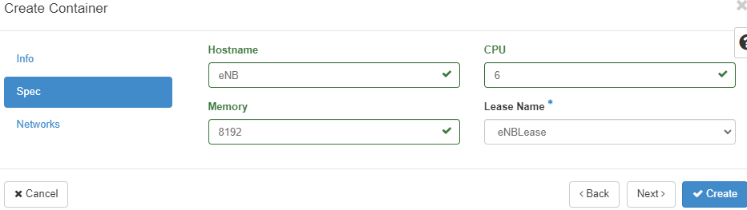

1. Click the up arrow for ARA_Shared_Net in Networks tab, making sure that it moves to the Allocated section, then click create.

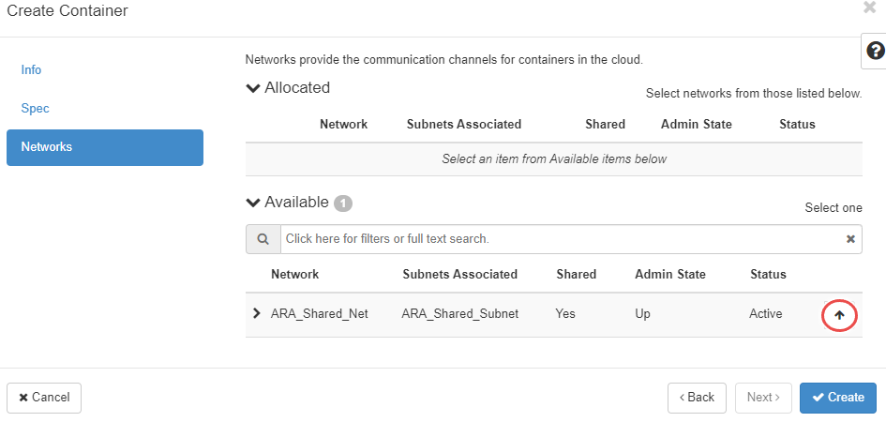

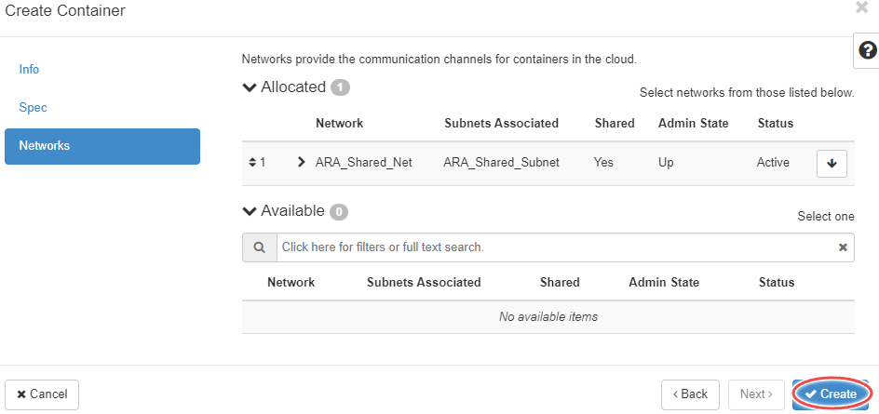

1. If done correctly, a message saying successfully created will appear at the top right. It might take a few seconds for the container to get up and running while waiting create the second container.

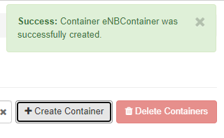

1. For the second container, it is recommended to use the name “UEContainer” and use the image arawirelesshub/srsran:srsue_4g. For the Spec tab, use all the same specs except **Hostname:** UE and **Lease Name:** UELease.

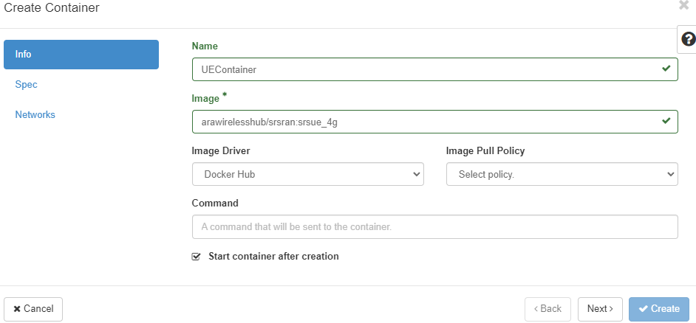

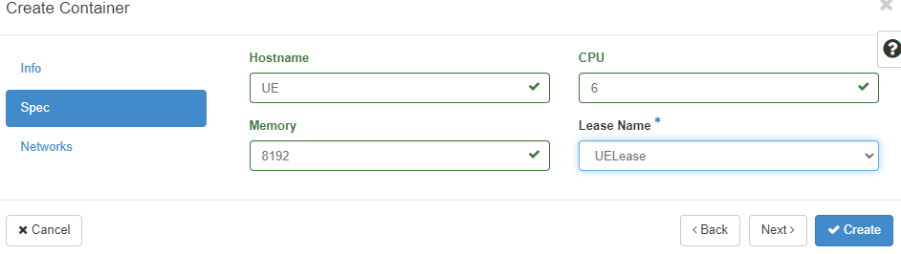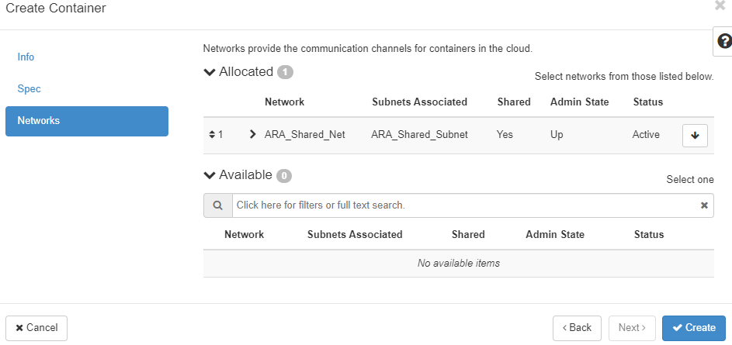

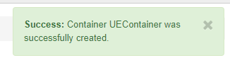

1. Provide a screenshots of both of the successfully created containers’ overview tabs. Go to the container overview by clicking on the blue container name.

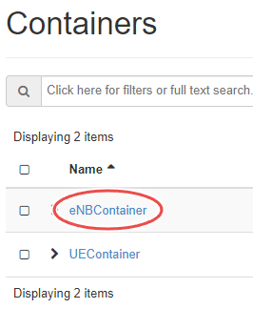

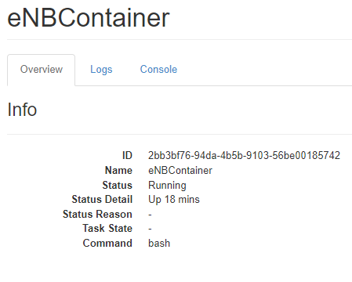

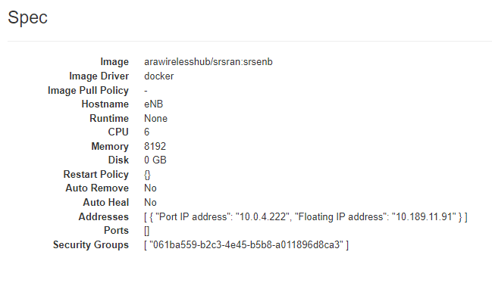

# Connect to containers using jumpbox.

* 1. Select the eNBContainer and go to the Console tab.



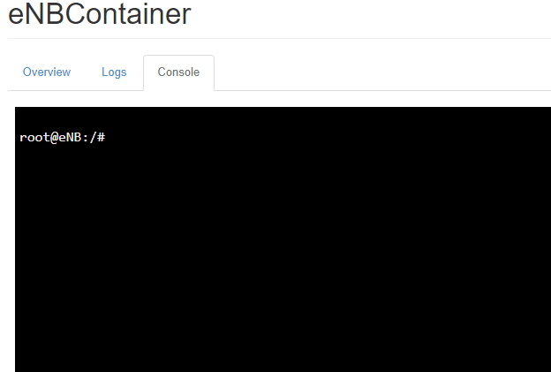

* 1. Run the command passwd using a password you won’t forget “root” is recommended, then start the ssh service using the command service ssh start .

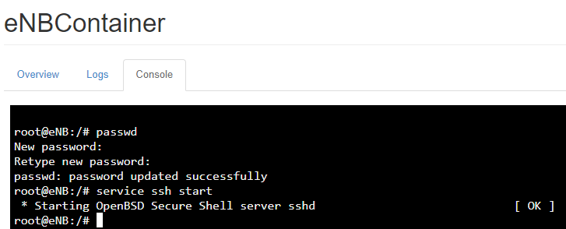

* 1. Do this for the UEContainer as well.

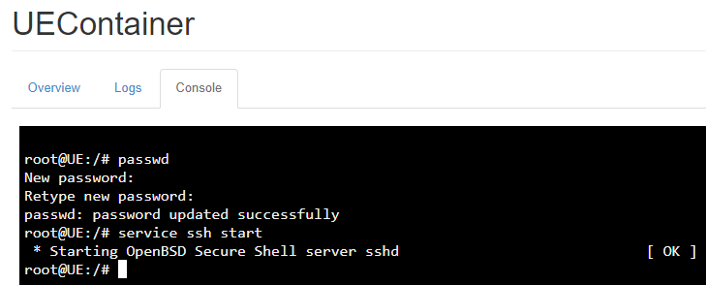

* 1. Open a two terminals or command prompt windows and ssh into ARA’s jumpbox username@jbox.arawireless.org. Make sure that the RSA private key you used to sign up for ARA’s jumpbox is in the .ssh file on the machine you are using.

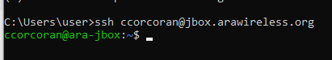

* 1. Go back to overview of eNBContainer, under specs a floating IP address is listed. This is the Ip address you will use to ssh from ARA’s jumpbox to the container using username root and the password you chose.

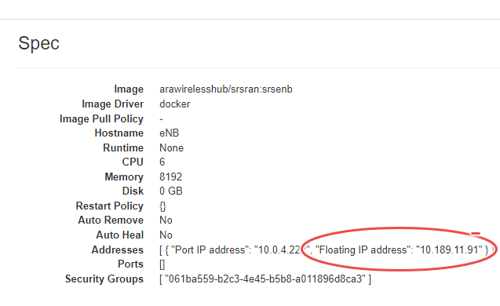

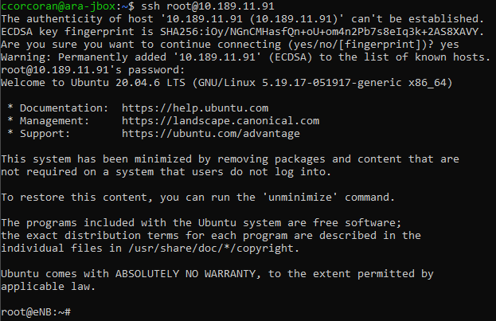

* 1. Open another two terminals for UEContainer as well.

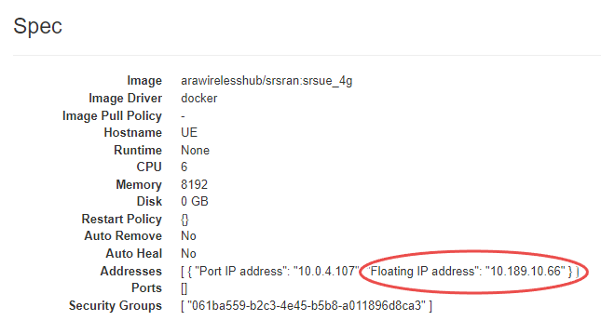

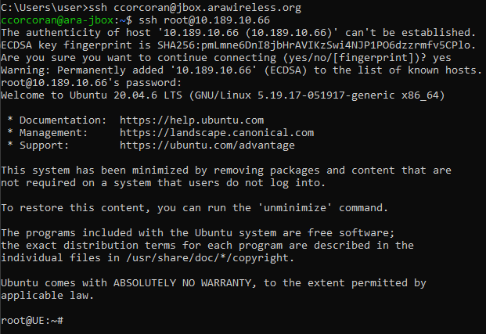

# Starting the EPC and eNB

* 1. In on the the terminal for eNBContainer run the command srsepc & to start the EPC in the background then run the command srsenb.

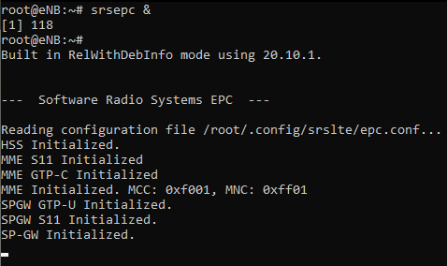 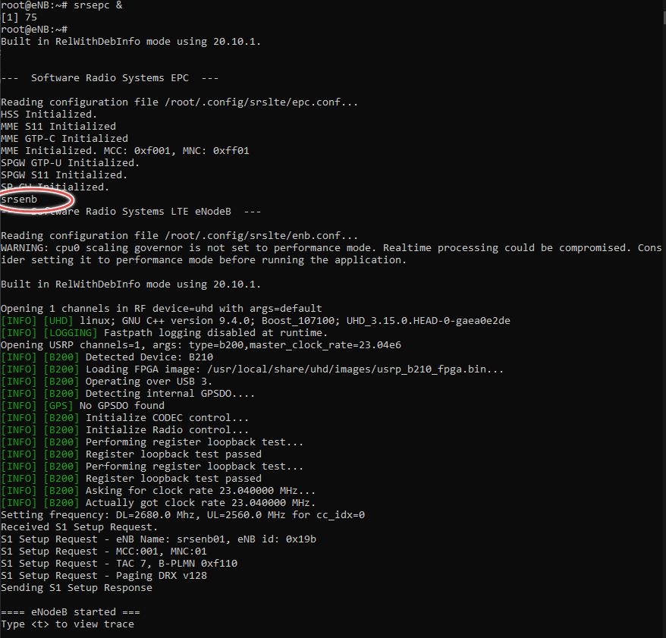

# Starting the UE

* 1. In one of the terminals for UEContainer run the command srsue

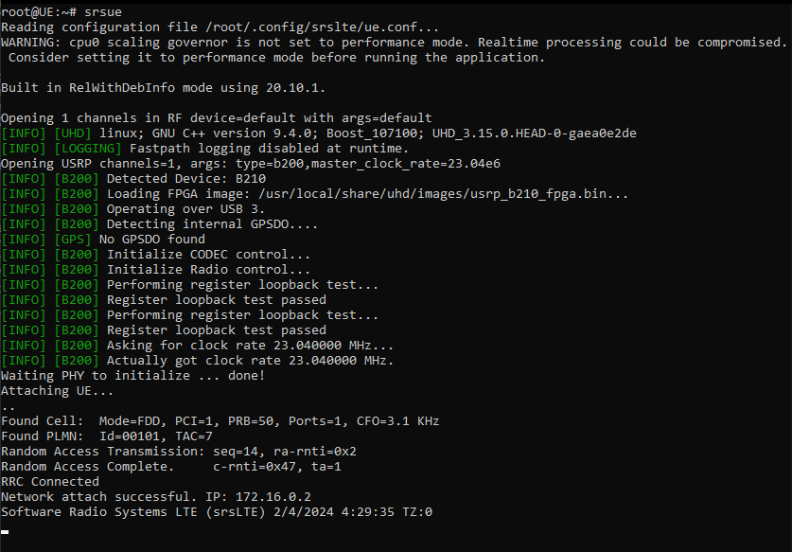

* 1. In the other terminal for UEContainer run the command ping 172.16.0.1 this will check that you are connected to the core. Provide a screenshot of your successful ping in your lab report.

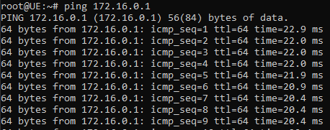

# Running the throughput test

* 1. In the terminals that are running srsenb and srsue type t and hit enter to start the console trace.

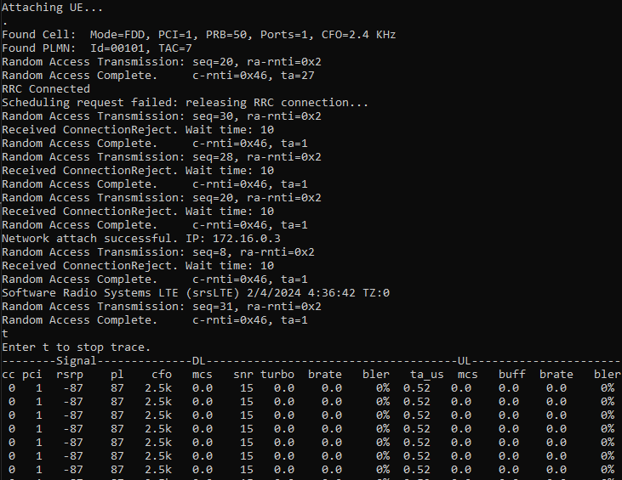

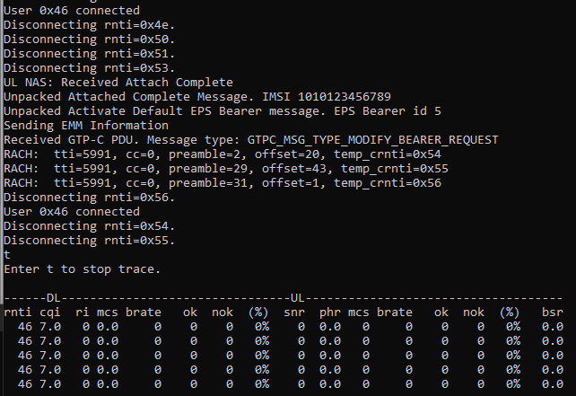

* 1. In the unused terminal for eNBContainer run the command iperf -s -u -i 1

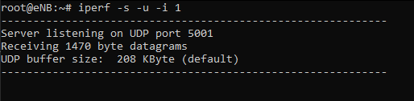

* 1. In the terminal for UEContainer used to run the ping command run the command iperf -c 172.16.0.1 -u -i 1 -b 25M -t 10

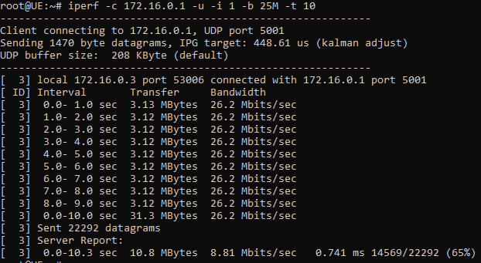

* 1. Provide a screenshot of both console traces in your lab report. Typing t and hitting enter will stop the console trace. Type t and hit enter again to start it again.

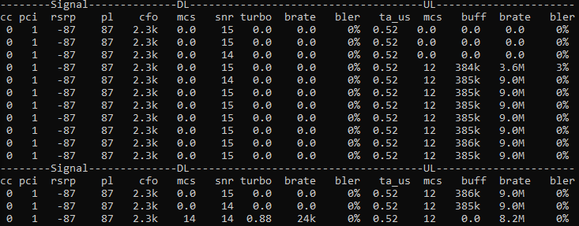

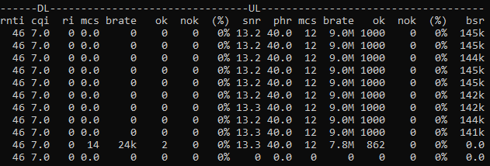

* 1. In the lab report, define the options for iperf used for the UEContainer and define the brate seen in both console traces.
  2. Run the command iperf -c 172.16.0.1 -u -i 1 -b 25M -t 10 but change the value for the -b flag to make a noticeable difference in the brate. Provide a screenshot of the console traces and the value for -b that was used.

# (Optional) create new UE

* 1. To see the effects that the distance between the UE and eNB can have on throughput, find another Sandbox-Host that is further or closer to the eNB. Delete the lease for the current UE, make a new one, and rerun the experiment.
  2. Describe the changes you observed in you lab report.

# Deleting Leases

* 1. Navigate to Reservations → Leases and use the box next to Lease name to select both leases, then click Delete Leases.

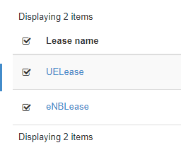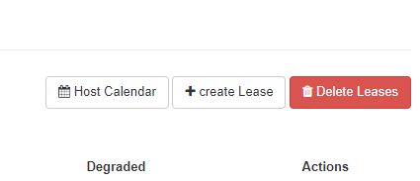

* 1. Provide a screenshot of the empty Leases page in your lab report.

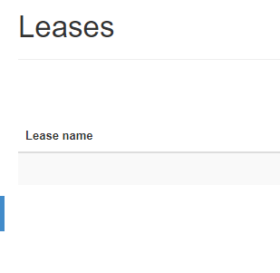

Lab report template:

1. Lease details screenshots
   1. eNBLease:
   2. UELease:
2. Container overview screenshots
   1. eNBContainer:
   2. UEContainer:
3. Screenshot of ping 172.16.0.1 results
4. Console trace screenshots
   1. eNBContainer:
   2. UEContainer:
5. Define the options used by the UEContainer iperf command. The [iperf man page](https://linux.die.net/man/1/iperf) can be used.
6. Define the brate metric given by the console trace.
7. Console trace screenshots with different -b value
   1. New -b vlaue:
   2. eNBContainer:
   3. UEContainer:
8. Empty lease page screenshot
9. (Optional) describe the effect distance has on throughput in a 4G network.