Iowa State University

4G LTE Network Emulation and Throughput Testing Utilizing ARA

Senior Design sdmay24-20 Lab Report



Before starting this lab, familiarize yourself with the basics of 4G network infrastructure by visiting [A Beginners Guide to Mobil Communication Infrastructure](https://www.packetcoders.io/a-beginners-guide-to-mobile-wireless-communication-infrastructure/) and reading the section regarding 4G networks. To understand the platform that you will be using read about the ARA sandbox [ARA Sandbox Service](https://arawireless.readthedocs.io/en/latest/ara_technical_manual/sandbox_service.html).

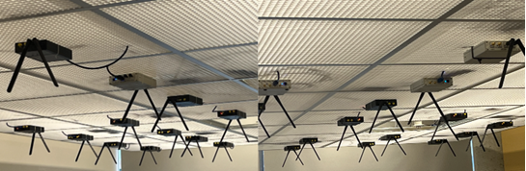

Lab Report Template:

1. Lease details screenshots
   1. eNBLease:
   2. UELease:
2. Container overview screenshots
   1. eNBContainer:
   2. UEContainer:
3. Screenshot of ping 172.16.0.1 results
4. Console trace screenshots
   1. eNBContainer:
   2. UEContainer:
5. Define the options used by the UEContainer iperf command. The [iperf man page](https://linux.die.net/man/1/iperf) can be used.
6. Define the brate metric given by the console trace.
7. Console trace screenshots with different -b value
   1. New -b vlaue:
   2. eNBContainer:
   3. UEContainer:
8. Empty lease page screenshot
9. (Optional) describe the effect distance has on throughput in a 4G network.